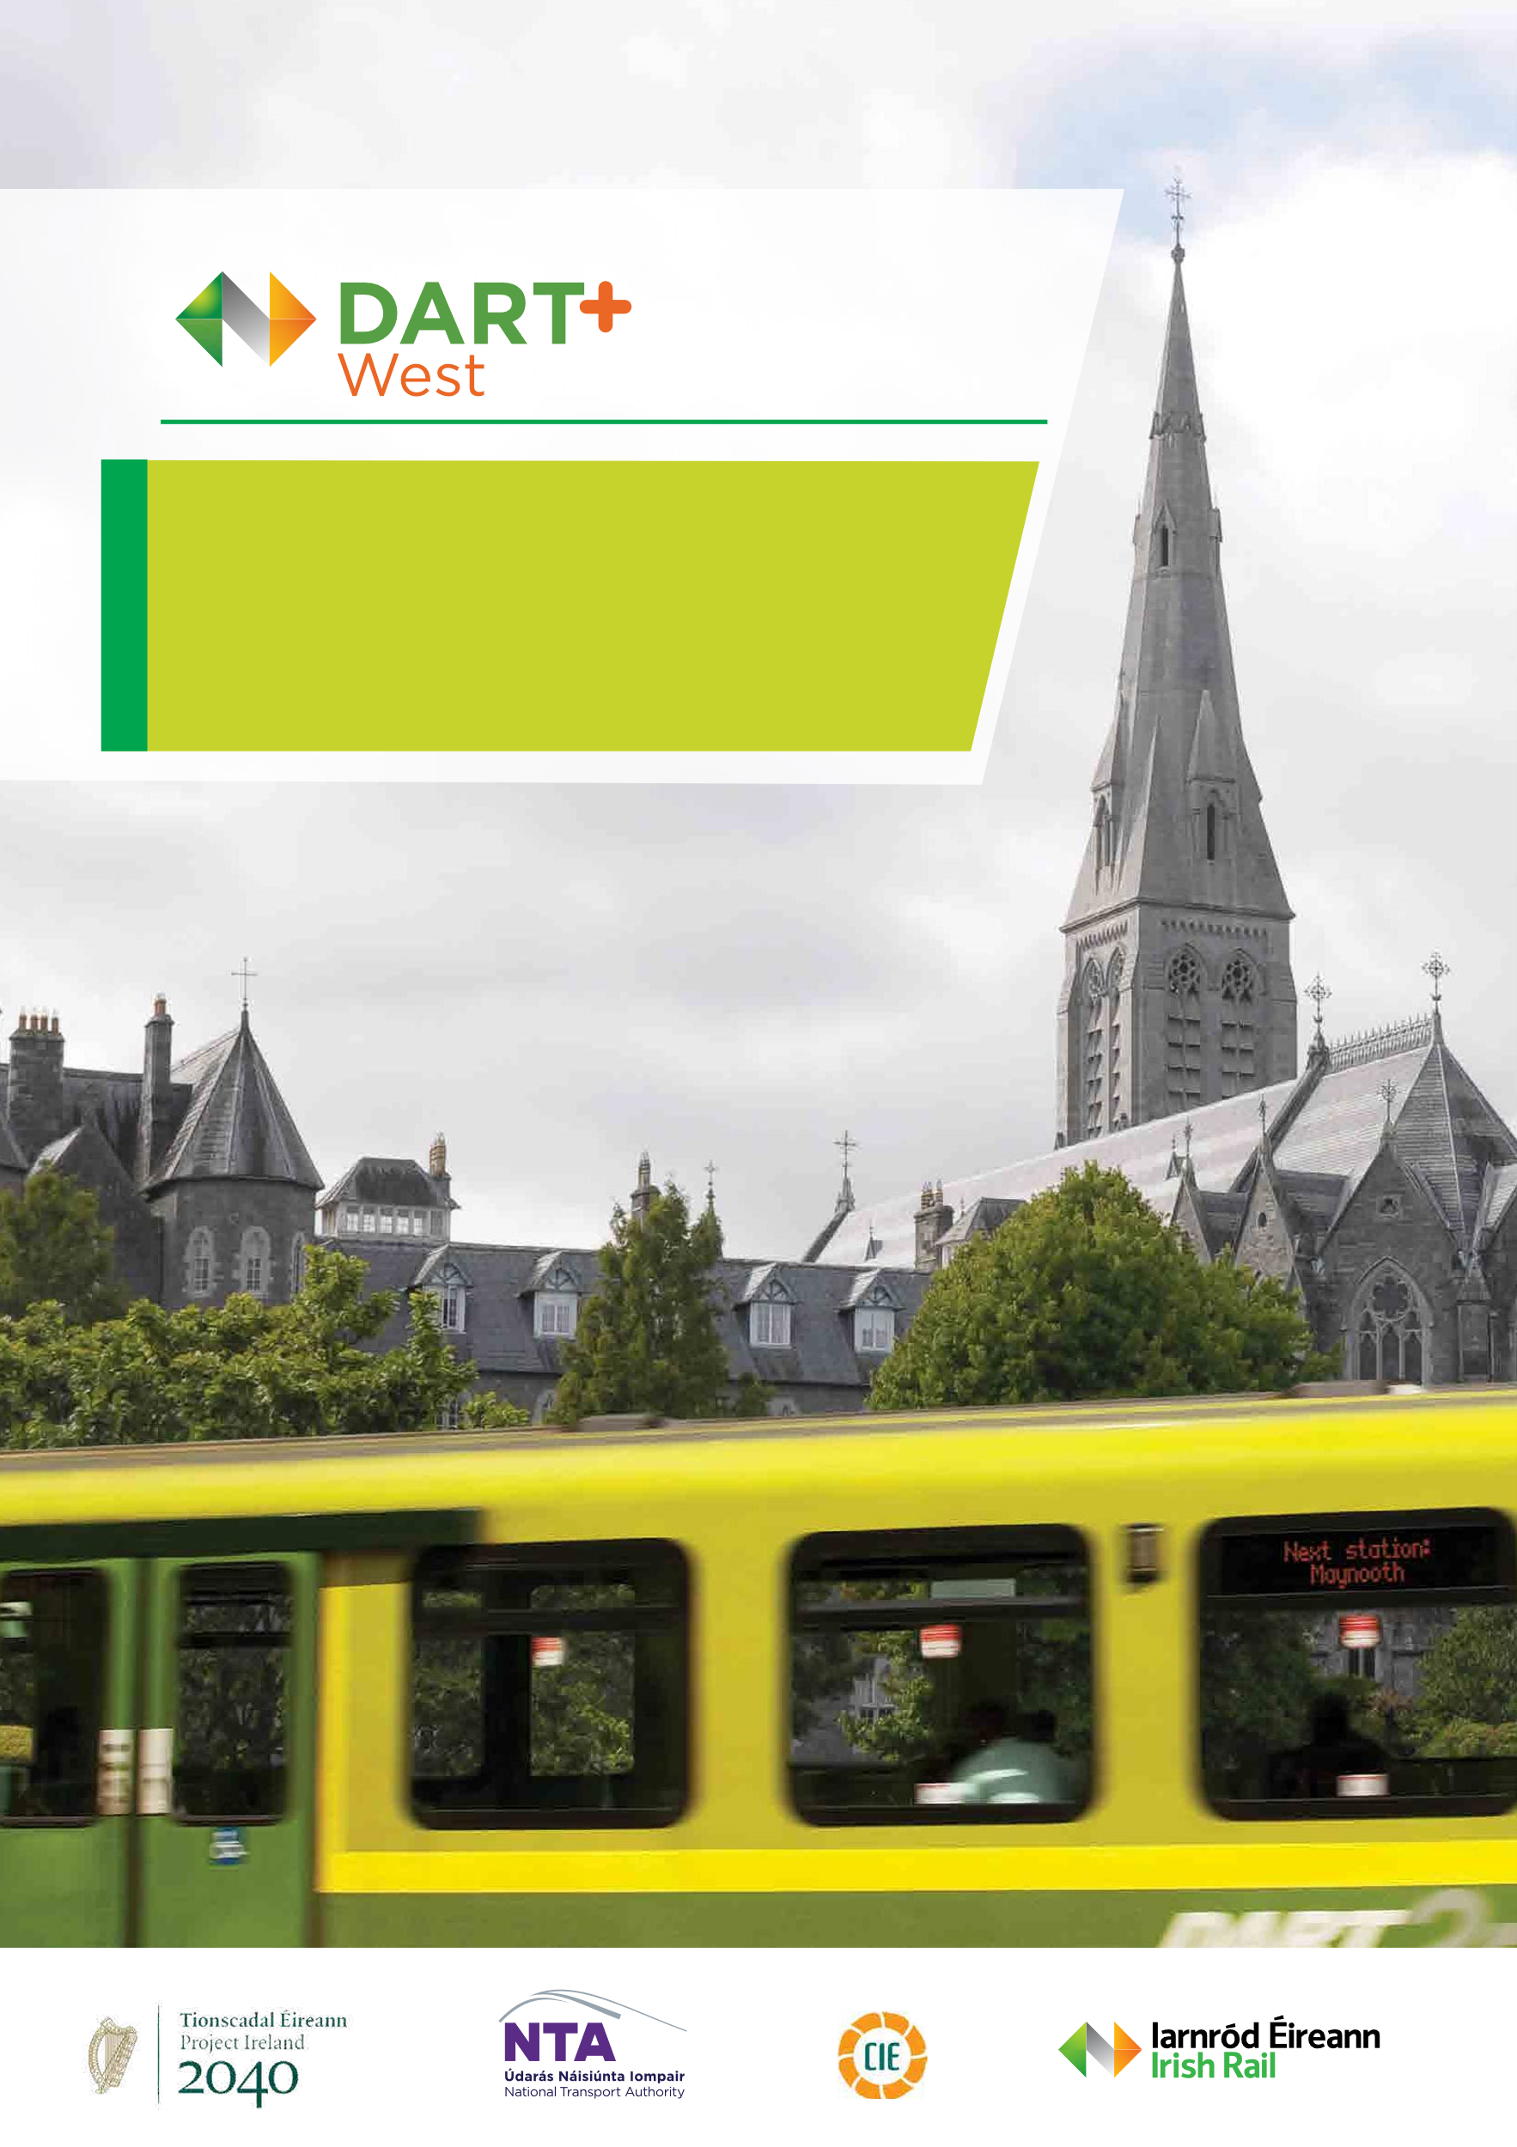

Submission on Observations to the Draft Railway Order Application
Addendum
August| 2023

Table of Contents
introduction to addendum 1
3.39 Ref.41 – LO101 – Patrick Walsh 1
3.39.1 Submission, Location – Depot 1
3.39.2 Response to Submission 1
3.40 Ref. No.42 – LO102 – Eamon & Joseph Kelly 3
3.40.1 Submission, Location – Depot 3
3.40.2 Response to Submission 4
3.41 Ref. No.43 – LO103 – Eileen & James Foley 4
3.41.1 Submission, Location – Depot 4
3.41.2 Response to Submission 4
3.42 Ref. No.44 – LO104 – Peter Maher 5
3.42.1 Submission, Location – Depot 5
3.42.2 Response to Submission 5
3.43 Ref. No.46 – LO132 – McGarrell Reilly Homes 5
3.43.1 Submission, Location – M3 Parkway Station 5
3.43.2 Response to Submission 5

introduction to addendum
This Addendum supplements the ‘Submission on Observations to the Draft Railway Order Application’ Report submitted to An Bord Pleanála in May 2023. It should be read in conjunction with the report published in May 2023. These responses should be read as part of Section 3 of that document and have been numbered accordingly. As stated in the main document any commonly raised issues are grouped in Section 2. These are broken down into scheme wide issues and location specific issues.
Additionally, if it is the case that we have not responded to an issue raised in a submission, this should not be taken as an acceptance on the part of IÉ of that issue, or anything set out in the submission, unless we have expressly stated such acceptance.
The below submissions are supplementary to Section 3 of the report published in May 2023 and have been raised by individual landowners.

Ref.41 – LO101 – Patrick Walsh
Representative – Not Applicable

Submission, Location – Depot
Issues raised in submission are addressed with their responses below.

Response to Submission
Summary of issue raised
- The observer's livelihood, which is solely in farming, will be profoundly affected as the dairy cows can’t travel far and have to be close to the farmyard, and the proposed Depot is planned to be built on the same field as the farmyard.
Response to issue raised
The Railway Order for the DART+ West project will involve total land take of 6.3110ha permanent agricultural lands from a dairy farm holding with a farmed area of 93.0ha of owned and rented lands at this location.
The impact of the proposed development has been assessed in the EIAR and the significance of this impact is deemed to be ‘Significant’. This assessment has considered the area of land take, the reduction in lands available to the dairy herd and the temporary and permanent impacts on the operation of the dairy enterprise. The boundary of the proposed Depot is approximately 190m from the farmyard.
The ‘Significant’ impact results from the area of land being acquired, which is of such a scale that the mitigation required to continue operations are considered as significant.
Summary of issue raised
- Queries how CIÉ propose to control the Stray Voltage which the observer believes would have a severe affect especially on their dairy cows.
Response to issue raised
In relation to stray voltage effects having a severe effect on dairy cows, the term “stray voltage” the phenomenon to which the term refers is not immediately clear. However, it has been considered to be either one of two things; stray current or electromagnetic radiation. Firstly, it may refer to the potential difference which will exist between the train lines and the surrounding earth which leads to the possibility of stray current passing through buried parallel conductive structures. The prevalence of stray currents is mitigated against in the system design so that the system will run more efficiently through minimising stray currents. Regardless, stray currents are not known to have any effect on livestock. Secondly, if the query is in relation to electromagnetic radiation then the following response has been presented. The traction system will be DC in nature and therefore will generate a DC magnetic field. The DC magnetic field levels generated by the development will be lower than the earth’s magnetic field to which all livestock is continually exposed. The Depot will be supplied via the pre-existing 38 kV Kilcock-Moneycooley overhead line. Electromagnetic fields from the electricity grid are non-ionising. This term means that they do not have enough energy to cause damage to human or animal cells in the same way ionising radiation (such as Ultraviolet) does. Also, the 38 kV AC overhead line is already present in the area and does not pose any health risks. The supply for the Depot will be tapped off of this pre-existing line.
Summary of issue raised
- Queries how CIÉ propose to control sound especially during construction and thereafter as any sudden loud noises will spook the cows.
Response to issue raised
The EIAR, Chapter 14, Section 14.5.3 assesses the construction phase impact of the project. The majority of the construction work associated with the Depot is not expected to generate sudden loud noises and will instead be characterised by engine noise from construction machinery. However, some activity is identified as having a potentially significant impact for short periods of time. Mitigation measures are outlined in Section 14.6.1 to reduce these impacts.
Section 14.5.4.6.8 of the EIAR assesses the noise impact as a result of the Depot operation. This assessment includes maintenance, cleaning and stabling activities as well as fixed plant serving the depot and movement of EMU’s within the depot area. The assessment has concluded that the noise levels beyond the boundary of the depot are not significant.
Summary of issue raised
- States that rare Field Maple is found on their land.
Response to issue raised
The Royal Canal and adjacent habitats form an ecological corridor. This is reflected in the EIAR, which lists both the ‘Royal Canal pNHA’ and the ‘Railway line Ecological Corridor’ as Key Ecological Receptors.
The dominant habitat at the depot lands is arable farmland, with some pasture at the eastern and western sides. These habitats are not important for biodiversity themselves, but they can link areas of greater biodiversity value and act as a buffer zone. The Royal Canal, the Lyreen River, the Ballycaghan Stream, treelines and hedgerows at the depot site are of greater biodiversity value. In particular, the treelines at the eastern end of the depot site consist of mature oak and ash trees.
The levels of protection afforded to the habitats and species are stated in the EIAR Biodiversity Chapter Section 8.2 (Legislation, Policy and Guidance). The protections afforded to individual species are described in Sections 8.4 (Desk Study Results) and 8.5 (Field Survey Results).
Impacts on biodiversity (noise, vibration, lighting, visual disturbance etc) are identified in the EIAR Biodiversity Chapter Section 8.8 (Description of Potential Impacts (unmitigated)). Table 825 presents the unmitigated construction and operational phase impacts on each Key Ecological Receptor. The Key Ecological Receptors include Badger, Otter, Bats and Birds. Mitigation is presented in Section 8.9. The residual impacts on the Key Ecological Receptors, following the application of the mitigation measures, are presented in Section 8.10. Although it has not been possible to eliminate all impact on biodiversity on an infrastructure project of this magnitude, the impacts on Key Ecological Receptors have been reduced to sub-significant levels.
Field Maple, although a rare tree in a natural setting is considered to be an introduced species. Individual trees are not of conservation importance and are not afforded any legal protection.
Summary of issue raised
- The proposal to dig out 1m deep of ground to control flooding puts their property and that of others under severe threat of flooding.
Response to issue raised
The compensatory storage areas have been designed to control flood waters in extreme weather events. Flooding will be confined to the specified areas up to the 1 in 1000 year event (+ climate change factor). It should be noted that the depth of excavation required varies and that the excavation of higher areas will not result in a higher flood level at that location.
Summary of issue raised
- The natural flooding plain of the Ballycannon / Lyreen River Valley should be reinstated before digging out good agricultural land.
Response to issue raised
As described in the scheme flood risk assessment the current flood regime of the Lyreen and its tributaries is a result of historic modifications to the catchment and network of watercourses (primarily the construction of the canal and railway). The result of these modifications is that flood waters are attenuated upstream of the Lyreen railway/canal culvert that would have originally reached Maynooth town downstream. As such reinstating the natural floodplain would likely increase flooding in Maynooth town centre. This would be contrary to the OPW Guidance on Flood Risk Management.
Summary of issue raised
- The owner notes that there has always been a Right of Way from their land into the Maws Farm and over the Railway and Canal and also a Right of Way for them to travel with farm machinery through the Maws Farm out to the main Maynooth/Kilcock public roadway.
Response to issue raised
There is no right of way in favour of Patrick Walsh registered with the PRAI (Property Registration Authority Ireland) in relation to the lands in question or on the records obtained for Maws Farm, lands that are registered to Carlos Clarke Ltd.

Ref. No.42 – LO102 – Eamon & Joseph Kelly
Representative – Corr Property Consultants Ltd.

Submission, Location – Depot
- Surplus Land Acquisition
- Drainage - Inadequate drainage details have been provided.
- Noise - Inadequate information has been provided.
- Screening and Planting
- Boundary Treatment
- Levels - inadequate details have been provided for the development.
- Lighting - Insufficient detail has been provided
- Setback Distances - The setback distance for buildings from this development has not been determined or clarified. This needs to be agreed as part of the design requirements.

Response to Submission
- Detailed responses to points 1 to 5 of this submission are provided in Sections 2.7.4 – 2.7.8 of the Submission on Observations to the Draft Railway Order Application report.
- Levels - The EIAR Volume 2 Chapter 5 Landscape and Visual Amenity proposes establishment of new native tree (including fastigiate trees), shrub and hedgerow planting. The planting proposed is a mix of local species integrated into the local environment, limiting the visual impact of the depot facilities.
- Lighting - detailed responses to point 7 of this submission is provided in Section 2.7.9 of the Submission on Observations to the Draft Railway Order Application report.
- Setback distance - Details of the proposed buildings are provided in the following:
  - Railway Order Structures Drawings, Specific Locations, Depot area drawings,
  - EIAR Volume 3A Technical Figures, Chapter 4, Specific Locations, Depot and
  - EIAR Volume 2 Chapter 4 Section 4.11.12.

Ref. No.43 – LO103 – Eileen & James Foley
Representative – Corr Property Consultants Ltd.

Submission, Location – Depot
- Surplus Land Acquisition
- Drainage - Inadequate drainage details have been provided.
- Noise - Inadequate information has been provided.
- Screening and Planting
- Boundary Treatment
- Lighting - Insufficient detail has been provided
- Environmental Impacts - The proposed development will have significant adverse effects on the environment and the impact will be such on human beings, livestock, fauna and flora, soil, water, air, climate, the landscape, as to cause irreparable damage to the local environment.

Response to Submission
- Detailed responses to points 1 to 6 of this submission are provided in Sections 2.7.4 – 2.7.9 of the Submission on Observations to the Draft Railway Order Application report.
- Environmental Impacts – The Environmental Impact Assessment Report (EIAR) submitted as part of the Railway Order application for the DART+ West project assesses the potential effects of the project on the environment. The EIAR chapters provide an impact assessment on the environmental factors in accordance with EIA Directive 2011/92/EU, as amended (the ‘EIA Directive’). In relation to the aspects of the environment mentioned in this submission, these are covered under the following EIAR Chapters:
- Human beings: Chapters 07 Population, 12 Air Quality, 14 Noise and Vibration, 22 Electromagnetic Effects and Stray Current, and 23 Human Health;
- Livestock: Chapters 16 Material Assets Agricultural Properties;
- Fauna and flora: Chapter 08 Biodiversity;
- Soil: Chapter 09 Land and Soils;
- Water: Chapter 10 Water (incl. Hydrology and Flood Risk) and Chapter 11 Hydrogeology;
- Air: Chapter 12 Air Quality;
- Climate: Chapter 13 Climate; and
- The landscape: Chapter 15 Landscape and Visual Amenity.
A Natura Impact Statement (NIS) was also submitted as part of the application which assessed the potential adverse effects on designated sites.
Where significant / adverse effects have been identified within these EIAR Chapters and the NIS, appropriate mitigation and monitoring measures have been developed to reduce the potential negative effects of the DART+ West project on the environment.

Ref. No.44 – LO104 – Peter Maher
Representative – Corr Property Consultants Ltd.

Submission, Location – Depot
Objects to their land being flooded at the depot. States that taking 1m depth of 3 acres at this level will make no difference to the flood plain, as no water will flow up there.

Response to Submission
The compensatory storage areas have been designed to control flood waters in extreme weather events. Flooding will be confined to the specified areas up to the 1 in 1000 year event (+ climate change factor). Excavations within the proposed compensatory storage areas will reduce ground levels allowing the areas to flood at existing flood levels. It should be noted that the depth of excavation required varies and that the excavation of higher areas will not result in a higher flood level at that location.

Ref. No.46 – LO132 – McGarrell Reilly Homes
Representative – McCutcheon Halley

Submission, Location – M3 Parkway Station
- Notes that there is no intention to temporarily acquire the access road to the M3 Parkway carpark. However, all construction traffic accessing the construction compound will use this access road, which is in the ownership of McGarrell Reilly (folio no. MH3028).
- Requests that access to McGarrell Reilly's remaining land holding to the south and east remaining open at all times. This is required to facilitate the future development of these lands in line with the planning policy objectives of the Meath County Development Plan 2021 to 2027.
- Requests for a condition survey of the access road (which is in the ownership of McGarrell Reilly) to be carried out before and after construction works commence and remediation of any deterioration in the road condition (including surface water drainage/gullies), footpaths and boundaries, after works have been completed. Immediate remediation works should be carried out if the road poses a Health and Safety risk at any point during the construction process. The existing road will provide access to future development lands to the south and east.

Response to Submission
- Noted, Irish Rail currently access the station through this road. Irish Rail commits to repairing any damage to the road as a result of the contract.
- CIÉ commit to maintaining access to these lands.
- CIÉ commits to undertaking the required precondition and post construction surveys, remediation and construction period maintenance.

